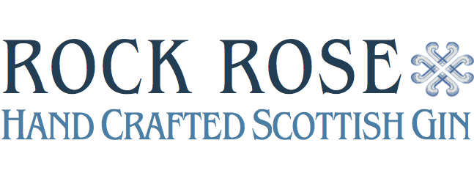

Introducing Rock Rose Gin
A truly unique gin, hand-crafted in the wilderness of North Scotland

Rock Rose Gin hails from Caithness in the far North of Scotland, where local botanicals are hand foraged from the cliffs and forests, to create a truly exceptional gin with a unique flavour profile. With the first batches selling-out pre-release, now is the first time gin-lovers across the country have the chance to get their hands on this award-winning tipple.
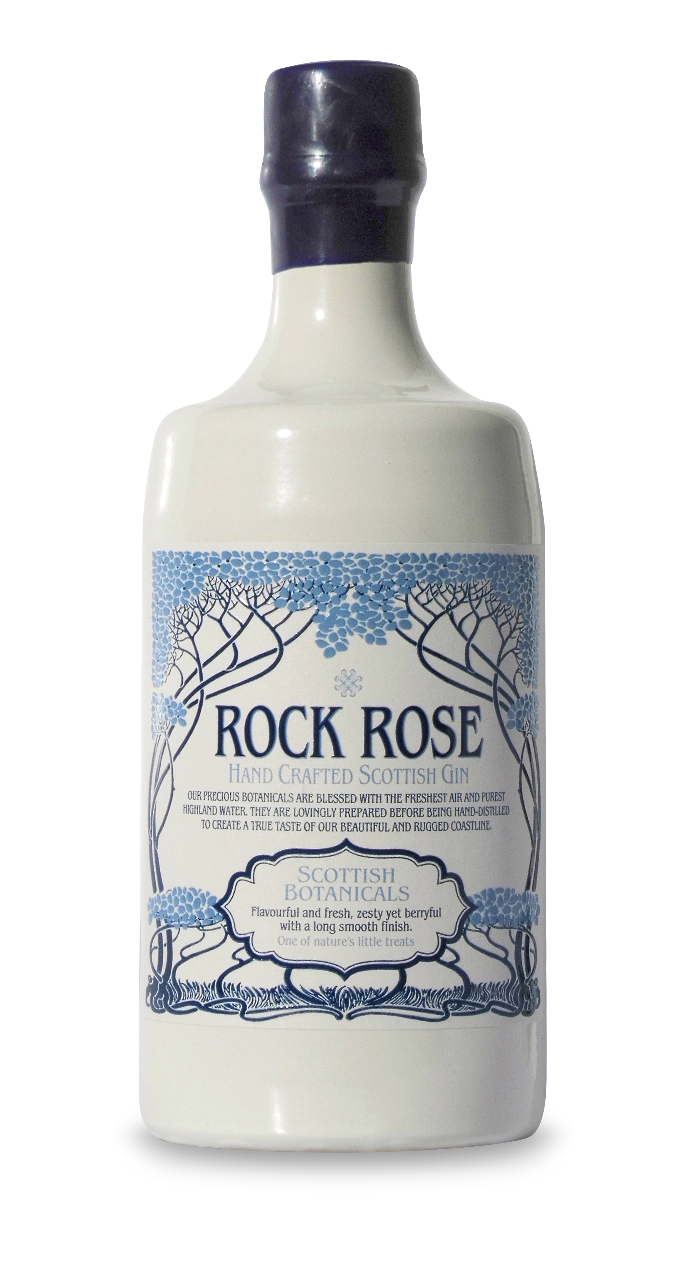
Distilled by hand, Rock Rose Gin is flavourful and fresh, zesty but berryful thanks to a carefully selected collection of local and traditional botanicals, each one meticulously chosen to create the perfect taste. In fact, its name comes from one of these botanicals, the Rhodiola Rosea (a rose in the rocks), which was discovered on the distillery’s first botanical forage along the Caithness cliffs and which adds a delicate floral note to the gin.

Also featuring Juniper Berries, Rowan Berries and Sea Buckthorn, the gin is carefully and slowly distilled by hand at the Dunnet Bay Distillery by husband and wife team, Martin and Claire, whose goal is to create a spirit which showcases the heritage and provenance of Caithness.

Martin Murray, Founder of Rock Rose Gin, says, “Rock Rose Gin has been three years in the making and features our unique ‘Rock Rose’, a precious plant that was once pillaged by the Vikings who believed it would give them extra strength and make them live to 200! We have been blown away by its sell-out success and the response from the industry to date, with it even winning awards as far afield as San Francisco. We are so proud to now be able to share our wee taste of the Highlands with the rest of the UK.“

Critical acclaim for both the taste and design of Rock Rose Gin is gaining momentum. Not only has the gin won a Bronze Medal for Best Gin at the world-renowned San Francisco World Spirits Competition, making it a top choice from the UK, it has also been named Best New Launch Design at the World Gin Awards 2015, all in the last month alone.

Find out more and order your bottle at www.rockrosegin.co.uk

- ENDS -

For more information, samples and pictures, please contact Jess Armstrong at jess@springpr.co.uk

Notes to Editors:
- Rock Rose Gin is available from www.rockrosegin.co.uk and selected retailers, with full details on the website
- RRP £34

